Project #5 | Visual Programming

# **Client**: Adaptive Technology Consulting + Evolution Fitness **Product Owner**: Joshua Wade + Gerald Griffin

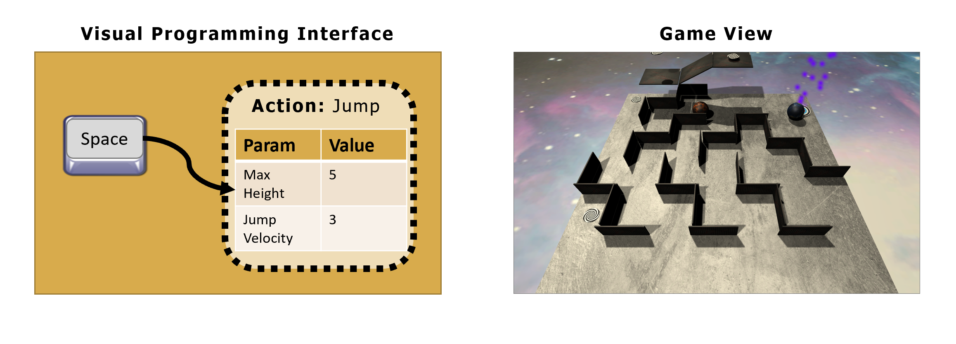

**Helpful Links**:

* [Windows Build of Original Project (.zip)](https://1drv.ms/u/s!AkaQTQvxP8TWgcAYpvuf9J7wQDYolQ?e=TWcf6r)
* [WebGL Build of Original Project (.zip)](https://1drv.ms/u/s!AkaQTQvxP8TWgcA2h3ItqkkKLUe7Pg?e=7iMKyL)

Requirements:

|  |  |  |  |  |
| --- | --- | --- | --- | --- |
| # | NAME | DESCRIPTION | IMPORTANCE *(0 to 100)* | NOTES |
| 1 | Create Unity Scene for the Visual Programming Editor | The team shall create a simple UI for a visual programming editor that includes the following components:   * A large canvas for creating visual associations between inputs and actions * A bank of available input options based initially on a keyboard + mouse input method * A build button to launch the Labyrinth game in a separate scene | 100 | Please use the most recent stable release of the Unity Editor: <https://unity3d.com/get-unity/download/archive> |
| 2 | Create Unity Scene for Labyrinth Build | The team shall create a simple Labyrinth scene that implements the following behavior:   * A player character (e.g., a sphere) that responds to inputs based on the visual program created in the Visual Programming Editor * A collection of walls defining both the path and boundaries of the labyrinth (feel free to be creative) * A method for returning to the Visual Programming Editor scene (e.g., through button press or when the course is completed) | 100 | Course completion logic is not required for this task, but the team is welcome to develop that if so desired. |
| 3 | Design UI for Input-Action Associations | The team shall design a simple UI—perhaps similar to the one shown in the figure on page 1—that allows the user to create visual associations between inputs and actions. For instance, the input SPACEBAR maps to the action JUMP.  **Set of Desired Inputs:**   * SPACEBAR * LEFT MOUSE CLICK * RIGHT MOUSE CLICK * UP ARROW / W * DOWN ARROW / S * LEFT ARROW / A * RIGHT ARROW / D * ESC   **Set of Desired Actions:**   * Jump * Movement (lateral, forward, backward) * Grow * Shrink * *be creative and introduce actions that you think would be interesting/fun | 100 | The graph method that is shown is simply a suggestion. The team is welcome to explore alternative methods. |
| 4 | Feature: Expose action parameters for customized behavior | The team shall extend the functionality of the UI in req#3 to enable the user to customize the behavior of actions by exposing parameters to the user. For instance, a JUMP action might include parameters for MAX_JUMP_HEIGHT and JUMP_VELOCITY. Again, the team is invited to be creative and to explore parameters that are of interest to the team. | 80  This is a “would be nice” feature. |  |
| 5 | Feature: TBD Feature to teach looping concepts | TBD | 60  This is a “would be nice” feature. | This is a TBD feature that would introduce the basic concepts of looping. The Product Owner will provide more information on this feature. |